Phi Alpha Honor Society fact sheet

What is an honor society?
- Student organization that recognizes academic achievement – students who have distinguished themselves among their peers.
- For certified honor societies, eligibility is based on academic ranking.
- Service is often encouraged, but not required.

What is the importance of an honor society?
- Participation builds bonds among students and connections with the school and community.
- Participation promotes support, community and belonging.
- Participation promotes student satisfaction, leadership development, retention, and grade point average.
- Participation provides opportunities for schools to comply with the Council on Social Work Education (CSWE) Implicit curriculum standard Educational Policy 4.1: Student Development.

Why is certification important?
- Phi Alpha Honor Society is a certified member of the Association of College Honor Societies (ACHS) www.achshonor.org/.
- Certification by ACHS requires adherence to strict guidelines for organizational excellence, transparency, participatory governance, and scholastic eligibility.
- Students may be invited to join a number of honor societies that are not certified due to lack of compliance with the guidelines and provide limited benefits. Most are not based on class rank and do not have local chapters. If you are considering accepting nomination to an honor society, ACHS provides information about how to judge the credibility of an honor society at https://www.achshonor.org/is-this-invitation-legit-.

What is Phi Alpha Honor Society?
- Social Work’s certified and largest honor society founded in 1962.
- Certified member, Association of College Honor Societies.
- 501(c)(3) Non-profit corporation.
- 466 active chapters in 50 states, DC, Canada & Puerto Rico.
- Members have achieved academic excellence by being ranked in the top 35% of students in their program. Students are invited into membership by the chapter’s Advisor.
- Members receive certificate and lapel pin. The membership fee is $30. Membership is lifetime and transferable.
- The International Bylaws and Chapter Handbook (which includes sample chapter bylaws and information about how to operate a chapter) are on the website https://phialpha.org/.

What are the benefits of joining Phi Alpha?
- Members have met high standards. Phi Alpha is known and respected in the Social Work academic and professional communities.
- Awards, grants, and scholarship programs.
- Scholarship and service-focused presentation opportunities.
- Build relationships with students, faculty, professionals, universities, and communities.
- Service-learning projects.
- Chapter meetings and leadership opportunities.
- Monthly trainings and meetings for students and Advisors hosted by the International Office.
- Professional development activities
- Strategies for online programs to operate a thriving chapter.
- Eligible for pay grade increase for incoming federal employees.
- Provide membership verification to employers and graduate schools.
- Official regalia including cords, medallions, and stoles. Online store.
- Build resume

How can I find out more?
- To see if your school has a chapter or who your advisor is go to https://phialpha.org/chapter-directory/.
- To contact the International Office e-mail phialphainfo@etsu.edu.

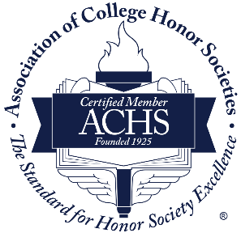

August 2023

